Assignment 1 (A1):

Information Visualisation

Find references to back up

Review, is it needed?

Worth a re-read – not 100% sure.

Data Set

Chosen data set: Abalone Data Set [4].

Data Structure

This data set contains 8 attributes with 4177 instances. There a number of data types, these include: Quantitative; Nominal.

Task to undertake with data

The user wants to be able to guess the age of the abalone, which is determined by the number of rings, that are within it, when it has been cut open. However, this process of cutting open the abalone is time consuming and fiddly.

Create a Design

Prototype 1

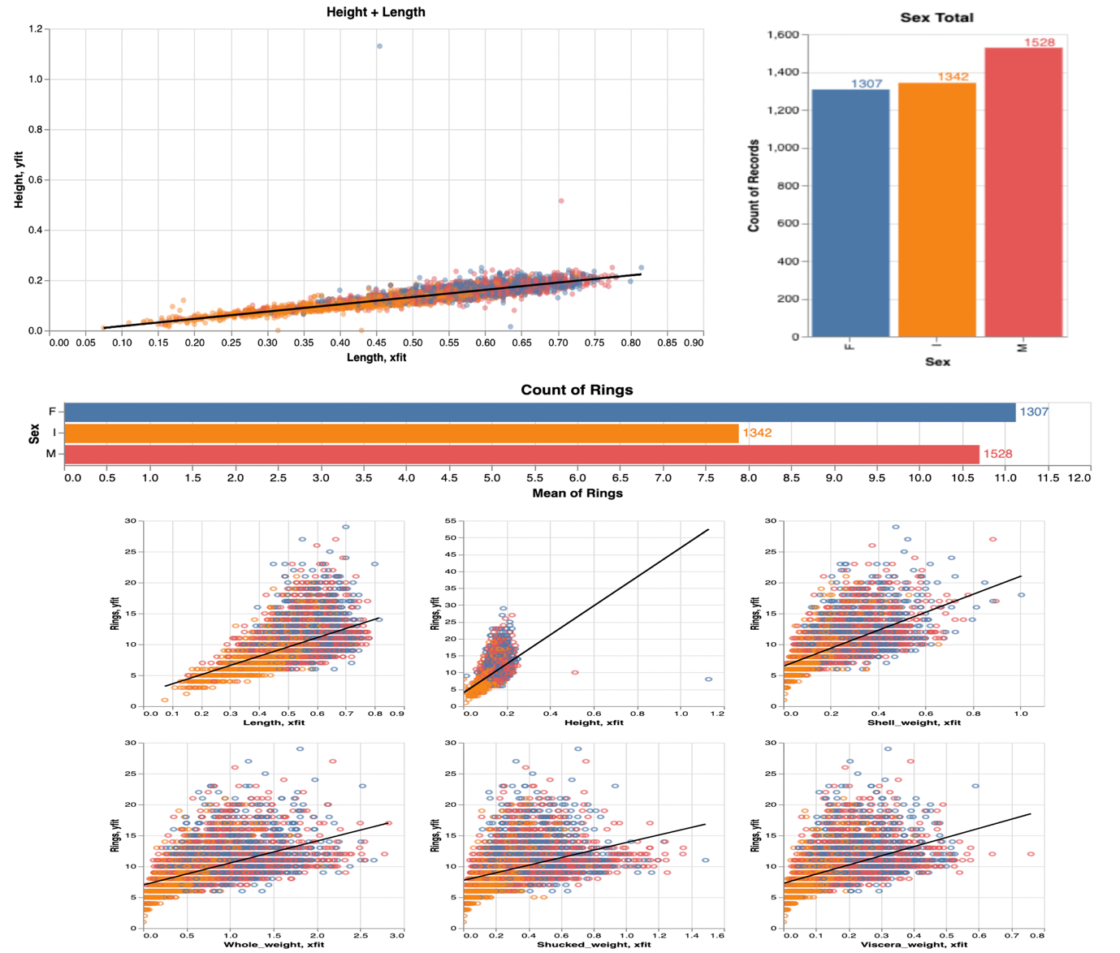

Description and justification:

The starting point for this design is getting a functional, effective system that provides all of the required tasks of the user. [1] So with this in mind the main aim was to make sure that all the required metrics are displayed for the user, to allow them to complete their task as best as possible. Due to humans only being able to deal with things in chunks, I have split the dashboard into vertical sections. Each section has relevant information, which is chunked to make it easier for the user to remember and compare. Also, to try and not overwhelm them with a lot of information in one go. With eyes being better than a person’s memory, having visualisations side-by-side makes it easier to compare [2]. There will be a level of animation, but this will be kept short. This is because it will be used while transitioning between different states [2] when the user has selected a section within the main graph. This subsection is then what will be displayed in the other visualisations, to help get a clearer picture. Scatter charts have been used as they are “Good for showing the relationship between two different variables where one correlates to another (or doesn’t).” [3] An alternative possibility is to use a bubble chart instead as they are good for expressing three numerical variables. [3] Bar charts have been used for the nominal data and the mean of rings. This is because using the categories to separate the values, bar charts allow the user to compare different values when specific values are important, for example, the number of the rings the selected Abalone have [3]. Radio buttons are available to the user to allow them to start filtering out data and see what is more appropriate for completing their task. As if the user has, for example, decided the Abalone is female, then they can remove the noise generated by the male and infant data to allow them to have a clearer picture and make a better decision. The scatter graphs will be placed together at the bottom as they are using similar attributes, which in my initial thoughts I think would have a relative correlation between them. So by them being side by side this will make it easier to compare the values. Each graph will use colours to differentiate the difference between the data points for Male, Female and Infants. This is to allow the user to be able to see the relevant data across all visualisations and know which data point is for what sex. The Hue of the colours will be bold, different colours to make this even easier for the user, as if saturated colours were used, then it means it will make the user have to think and distract away from the task. This, therefore, might make more errors prone to happening. The graphs will also display the data point values when the mouse hovers over the point or column. This is to allow the user to have all the required information they need at their fingertips, with minimal effort on their behalf. Again, this is to allow them to be able to focus on what their actual task is, guessing the age, not figuring out the data values.

** Talk about colours – What type and why- give reference to why colours are good (HUE)

** Hover over labels and labels with in the charts.

Note: Add references and this should be enough (unless from rereading and being concise it makes it too short).

Prototype 2

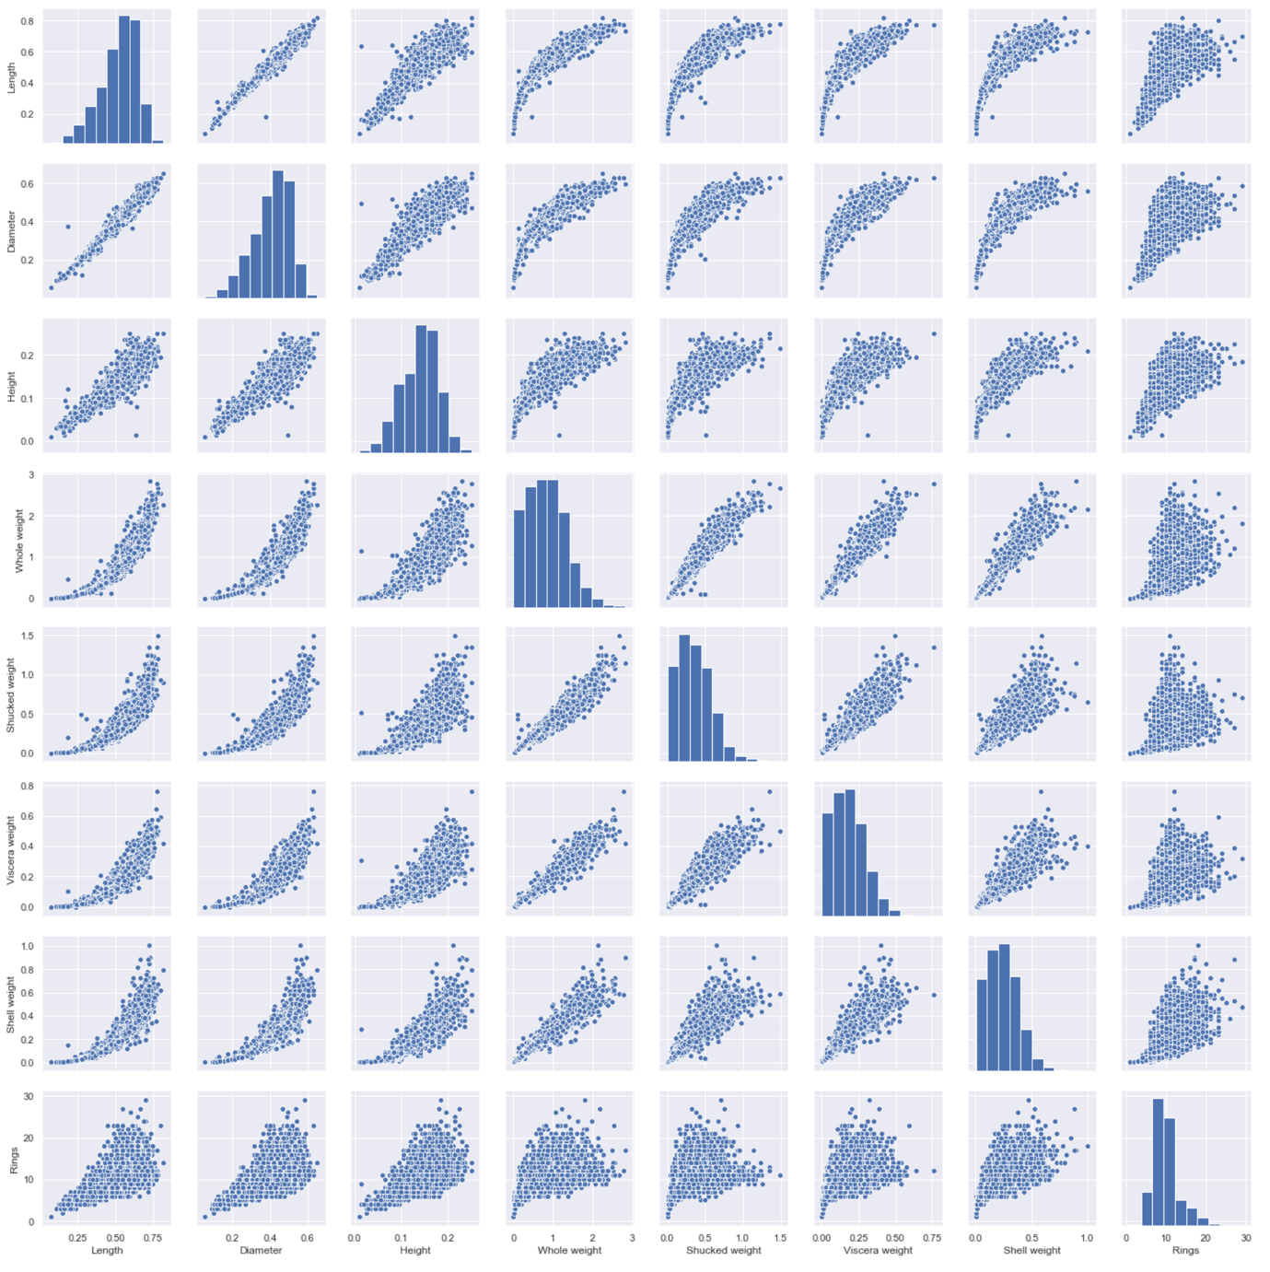

SPLOM.

Description and justification: (No references -> must find)

This design is first and foremost aiming to get all the potential measurement required by the user displayed functionally and effectively. The dashboard is presented again in vertical sections. This design will utilise the analytical technique (- is it? Or visualisation technique?) called Scatterplot Matrix (SPLOMS). SPLOMS are good as they allow you to be able to see multiple paired views, however, they take a lot of screen space. [6]

In order to make the SPLOMS as effective as possible, all the views will need to be linked together through interaction. This is to allow the user to be able to see the links between the different graphs while exploring the data.

To try and reduce the amount of graphs on the screen, the user will then be able to sub select keys features that they want to be able to compare. This will be dine using a selection box.

Analytical technique that will be applied is a dimension reduction technique called PCA. This is due to the data being vary big, with a lot of over lapping features. The aim will be, by using this technique, to reduce the amount of similarity but expand the spread of the variance. This is to allow their to be a better chance to decide on the outcome, which will be the number of rings. Dimensionality reduction aims to place similar features together, potentially allowing clusters to form which can then be found in lower dimensions like 2D. [7]

This will have two design sections. A top layer, which will focus on displaying the data within bar charts. This is to allow the user to be able to view different data, with the same process. This is due to the visualisation using the same style, removing unnecessary thinking from the user. (Why using bar charts? Good for comparison?)

The bottom half of the dashboard is using scatter graphs, again to make it easier for the user to keep using the same mindset but displaying different metrics. This is to help give them all the information that they will need to make a judgement on how old the Abalone is without cutting it open. (Why using scatter? Good for analysing?)

All the charts will be linked to the main bar chart, displaying all the relevant information required. This is to filter out any unnecessary data, to make the user be able to do what they need as easily as possible. So all the other bar and scatter graphs will only be displaying information that is linked to the highlighted area in the main bar chart. (Why link data charts together?)

The colours will be using a Hue variance. This is to make sure the data is made clear as possible for the user, as there are three main groups of data or nominal, then this makes it a good feature to set the charts colouring schemes on. (Why using Hue colouring?)

Note: adding in references should make this long enough.

Altair Code Implementation

Analytic technique: SPLOM?? Maybe

Data Discoveries

Charts can be cluttered. However, restricting data you don’t get a true result, however, too much data makes it hard to determine.

Within the data, there are a number of outliers. There are a few along the 0 y axis, also there are a few extreme data points that potentially skews the data. This would create a few issues if machine learning techniques were being used as this would have a great impact on training the model and skew the training. If machine learning was going to be used, I would suggest these data points being removed. (Need image + references).

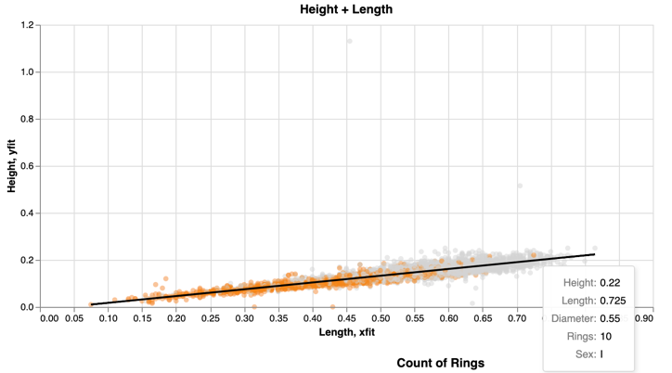

It is an assumption that the older an Abalone is, the bigger it is likely to be in both length and height. This could be said for all the other metrics. However, through exploring the data, being able to determine the sex of the creature is not as straight forward as determining the age and then using this as a factor to influence the decision on it’s chances of it being male or female. There are a few instances of the creatures being 11.5 years old and still being an infant. (need references and more images)

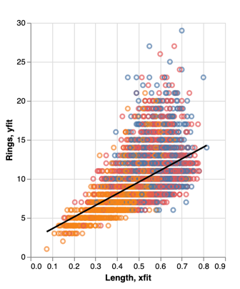

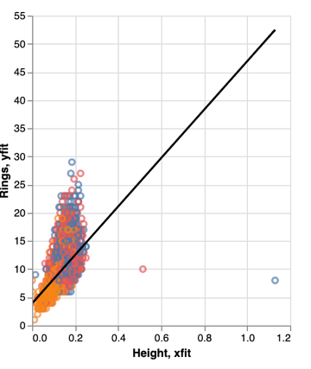

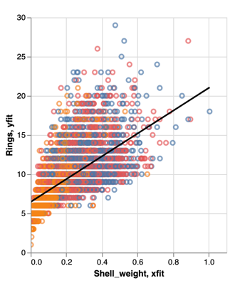

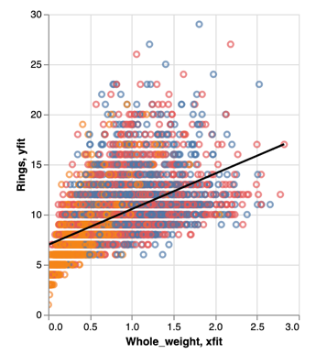

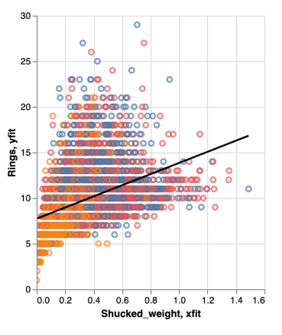

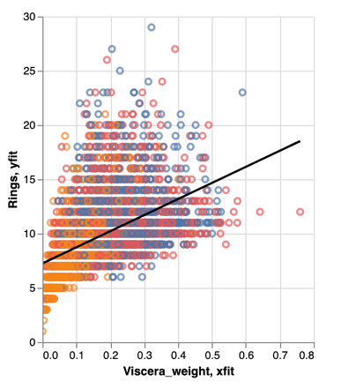

When comparing the weight metrics to the age of the Abalone, they all follow a very similar pattern. However, the whole weight of the snail and the shucked weight are very similar is data distribution, just different weights, but the viscera weight follows a similar patter as the other two weights but differ slightly. The viscera weight seems to be a lot more condensed and the data points are closer together, with only a few that look like outliers. For looking at the weight, you can see that just being the heaviest doesn’t mean that the snail is the oldest or just older than the rest. (Need references + tidy up images)

Talk about the category splits between M, F, I.

Also talk about the mean amount of rings for each sex.

The linear line matches up with same data in different charts. Think of example showed mum.

# Bibliography

**There are no sources in the current document.**

[1] Lecture slides: Visualisation Rule of thumb: Daniel Archambault: 2019, Slide 6

[2] Lecture slides: Visualisation Rule of thumb: Daniel Archambault: 2019, Slide 17

[3] EasyBI - <https://eazybi.com/blog/data_visualization_and_chart_types/> - Accessed [6/11/19]

[4] Dataset (<https://archive.ics.uci.edu/ml/datasets/Abalone>)

[6] Lecture 7 – Dan Anc - slide 9

[7] Lecture 10 – Slide 15

Ware, Colin – Information Visualisation: Perception for design 3rd edition (year?)

Munzner, Tamara – Visualisation Analysis & Design – 2015

Chen Min, Feixas Miquel, Viola Ivan, Bardera Anton, Shen Han-Wei, Sbert Mateu – Information Theory Tools for Visualisation – 2017

Good link about chunking up data : <https://junkcharts.typepad.com/junk_charts/2013/01/ruining-the-cake-with-too-much-icing.html>